September 16, 1999
To: Dr. Russell Butts, ABL-ACT Chief Scientist
From: Robert W. Praus, II, Principal Investigator, (505)245-9970
Subject: Derivation of a Waffle-Constrained Reconstructor (WCR)

Overview
This memorandum derives a Fried geometry wavefront reconstructor which generates actuator corrections having no waffle from subaperture slopes. I have made a number of simulation runs which indicate improved performance over the nominal MZA least squares reconstructor for simulated NOP test cases where waffle has been observed to be a problem. However, the analysis of the performance is not complete.
My intuition about the WCR is that it should have advantages over other methods of reducing waffle such as filters and projections. The WCR constrains only waffle and nothing else. Filter and projection methods present the possibility that corrections other than waffle are rejected. I suspect that WCR should provide improved performance over the other methods without any downside. With this in mind, I want to document the WCR approach so that other analysts can improve on it.

Derivation
For a Fried geometry, the slope influence function is often approximated through simple bilinear interpolation. For the subaperture shown in Figure 1, the equations for x and y slopes, s_{x} and s_{y}, given displacements, d_{i}, at the corners, c_{i}, are:
s_{x} = -d₁ + d₂ - d₃ + d₄ (1)
s_{y} = -d₁ - d₂ + d₃ + d₄ (2)
For a plurality of subapertures in a given Fried geometry, such as that represented in Figure 2, the typical approach is to use equations (1) and (2) and adjacency information to create the matrix A satisfying the equation:
Figure 1: Single Subaperture Geometry
s = Ad (3)
where s is the ordered x and y slopes across the subapertures resulting from displacements d at the corners of those subapertures. What is usually desired is a reconstructor matrix which, given measured slopes across subapertures, provides displacements at the corners which can be used to cancel the indicated wavefront error. These displacements are then used in a servo loop to drive mirror actuators located at the corners of the subapertures. The typical approach to obtaining a reconstructor for this system is to compute the pseudo-inverse of A, giving the equation:
d = A#s (4)
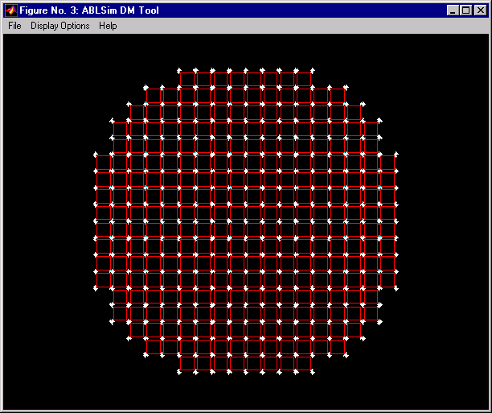
Figure 2: A Plurality of Subapertures Configured in a Fried Geometry
The pseudo inverse may be calculated in a variety of fashions, but usually one uses singular value decomposition (SVD) to obtain a system which minimizes the square error while suppressing the noise propagation of nearly unsensed (i.e., singular) modes.
This system can be modified to constrain waffle by incorporating the subaperture waffle equation
w = d₁ - d₂ - d₃ + d₄ (5)
with the subaperture slopes equations to create a matrix B, giving both subaperture slopes and waffle components, t, from displacements at the corners:
$t=\left[\begin{matrix}s_{x} \\ s_{y} \\ w\end{matrix}\right]=\left[\begin{matrix}\left[A_{x}\right] \\ \left[A_{y}\right] \\ \left[A_{w}\right]\end{matrix}\right]\text{d }=Bd$ (6)
Here A_{x}, A_{y}, and A_{w} are those portions of the matrix which relate to x slope, y slope, and waffle respectively. s_{x}, s_{y}, and w are subvectors containing the x and y slopes and waffle components for each subaperture. As before, this system gives rise to a reconstructor by taking the pseudo-inverse:
d = B#t (7)
t then must contain both slope and waffle measurements. Since the reason that we wish to constrain waffle is that it is an unsensed mode (or at least nearly so), a scheme requiring a measurement of waffle would be silly. However, we are not really after a measurement of waffle, we are after a reconstructor which provides sets of displacements which have no waffle. Examine the constituents of equation (7) further:
$d=\left[\begin{matrix}\left[B_{x}^{}\right] & \left[B_{y}^{}\right] & \left[B_{w}^{}\right]\end{matrix}\right]\left[\begin{matrix}s_{x} \\ s_{y} \\ w\end{matrix}\right]=B^{}t$ (8)
Taking a bit of liberty with notation, B# is comprised of three components: B_{x}#, B_{y}#, and B_{w}#. If we want to reconstruct a set of displacements representative of slopes s_{x} and s_{y}, while constraining waffle to be zero, we set w to zero and eliminate B_{w}# and w from the equation altogether. Hence there is no need for a waffle measurement and the following is obtained:
$d=\left[\begin{matrix}\left[B_{x}^{}\right] & \left[B_{y}^{}\right]\end{matrix}\right]\left[\begin{matrix}s_{x} \\ s_{y}\end{matrix}\right]=C^{}s$ (9)

Summary
C# is simply the waffle constrained reconstructor (WCR) matrix formed by removing the waffle-related columns of B#, which was obtained from a pseudo-inverse of a simple set of equations containing the waffle component equations. I believe that the characteristics of the WCR are as follows:
- The resulting actuator displacements, d, have no waffle, local or global. In fact, given the way that the matrix was formed, there really is no distinction between local and global waffle, since the matrix formulation is not dependent on a representation of waffle having a global component. Other approaches which are dependent on some symmetric geometry which gives rise to an orthogonal basis vector representing waffle run into difficulty when applied to a realistically discrete geometry.
- The formulation of the matrix is trivial.
- It is compatible with the use of other techniques such as SVD, projection operators, filters, and intensity weighting schemes.
- It can be applied in a real-time system employing a standard matrix multiply approach. It does not change the dimensionality of the problem, has the same inputs and outputs, and requires no programming changes whatsoever to the real-time matrix multiply system.
- It does not degrade the ability of a system to correct for wavefront errors having the same spatial frequency as the waffle mode.
- It does not effect one’s ability to handle difficulties such as annuli, partially illuminated subapertures, actuator slaving, and/or broken actuators.
As time permits I intend to investigate the comparative performance of the WCR with other reconstructors using ABLSim. Provided the results are positive, we may want to consider testing the reconstructor at NOP and ACL.

